**Lab: Converting Entity-Relationship Diagrams (ERDs) to Tables Assignment Instructions**

**Instructions**

In this assignment, you will convert an Entity-Relationship diagram into a set of related tables.

Given the following ERD, write the table definitions for the entities displayed below. You do not have to indicate data types nor “not null” constraints in this lab. Use the format TableName (attribute, attribute…attribute). Designate primary keys with an underline and foreign keys with a broken underline.

To illustrate, the Regions and Countries table definitions have been created for you below the diagram. Type your answers in this document and upload it to the appropriate Canvas assignment link.

Note that you should review **Read:** **Creating Tables Summarized** in the Learn section of this module. It was created to help you better understand how ERDs will ultimately be transformed into real tables.

**ERD for the Hourglass timekeeping database**

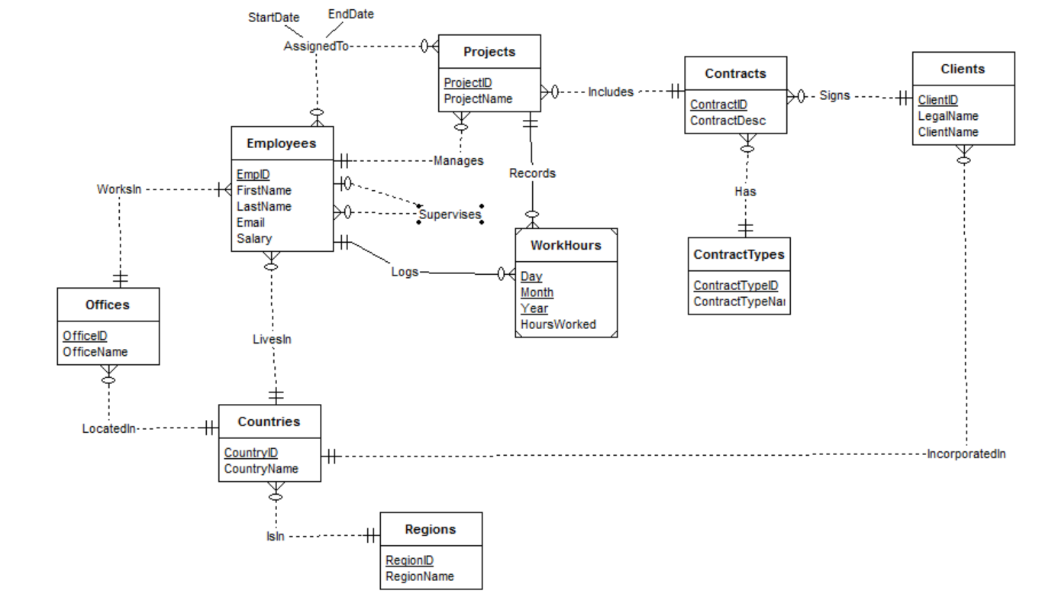

**Example**:

Regions (RegionID, RegionName)

Countries (CountryID, CountryName, RegionID)

Note: Your assignment will be checked for originality via the Turnitin plagiarism tool.

Submission

Regions (RegionID, RegionName)

Countries (CountryID, CountryName, RegionID)

Offices (OfficeID, OfficeName, CountryID)

Employees (EmpID, FirstName, LastName, Email, Salary, CountryID, OfficeID, EmpID, ProjectID)

Projects (ProjectID, ProjectName, EmpID, ContractID)

WorkHours (Day, Month, Year,HoursWorked, EmpID, ProjectID)

Contracts (ContractID, ContractDesc, ContractTypeID, ClientID)

ContractTypes (ContractTypeID, ContractTypeName)

Clients (ClientID, LegalName, ClientName, CountryID)